AIRLINE CASE STUDY

DONE BY: SIRISH SEKHAR

ROLL NUMBER: CS20B043

**DESIGN DESCISION:**

1.MULTIPLE SEPARATE CLASSES WERE CREATED IN ORDER TO APPLY THE OBJECT-ORIENTED DESIGN PRINCIPLES IN CLEAN AND CONCISE FASHION

AS SHOWN BELOW MULTIPLE OPTIONS HAVE BEEN GIVEN TO THE USER AND THE ADMIN THROUGH A MENU DRIVEN PROGRAM AND ALLOWS THEM TO USE THE APPLICATION WITH A HASSLE-FREE EXPERIENCE.

MAIN MENU

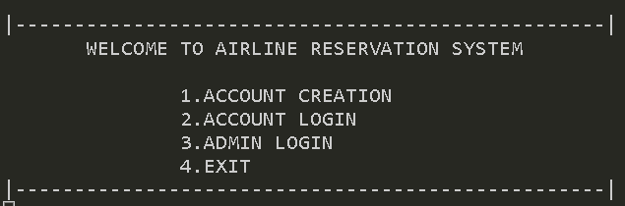

USER MENU

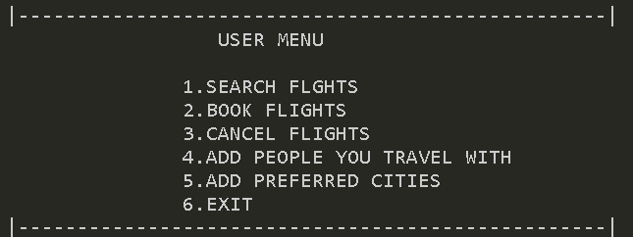

ADMIN MENU

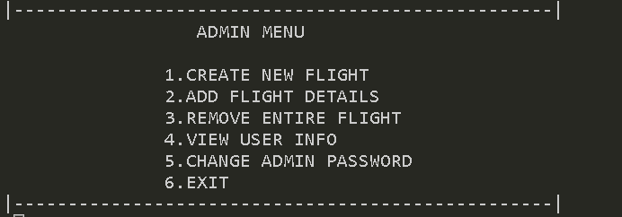

THIS IS VERSION 1 AND IS ALMOST COMPLETE THE TEST CASES WILL BE ADDED SOON ALONG WITH A COMPLETE REPORT MOST CONSTRAINTS HAVE BEEN SUCCESSFULLY SATISFIED.